Ex.no:2 | EDA-DATA IMPORT AND EXPORT

Aim:
To inspect dataset features, detect null values, and export data into CSV, Excel, and SQLite database formats.
Algorithm:
- Import pandas and sqlite3 libraries.
- Read hotel_bookings.csv using pd.read_csv().
- Inspect data structure using .head(), .tail(), .info(), .describe(), and .isnull().sum().
- Export DataFrame to .csv and .xlsx formats using .to_csv() and .to_excel().
- Connect to hotel_booking.db using sqlite3 and write data into an SQL table via .to_sql().
- Close the database connection and end execution.

Program:
import os
import pandas as pd

# Dataset path
path = "/content"

print("Dataset path:", path)

print("\nFiles in dataset:")
print(os.listdir(path))

# Find CSV file automatically
csv_files = [f for f in os.listdir(path) if f.lower().endswith(".csv")]

if not csv_files:
raise FileNotFoundError("No CSV file found in the dataset path.")

csv_file = csv_files[0]

print("\nCSV file:", csv_file)

# Load dataset
df = pd.read_csv(
os.path.join(path, csv_file),
encoding="latin1",
low_memory=False
)

print("\nFirst 5 rows:")
display(df.head())

print("\nLast 5 rows:")
display(df.tail())

print("\nDataset information:")
df.info()

print("\nShape:")
print(df.shape)

print("\nColumns:")
print(df.columns.tolist())

print("\nData types:")
print(df.dtypes)

print("\nStatistical description:")
display(df.describe(include="all").T)

print("\nMissing values:")
display(df.isnull().sum().sort_values(ascending=False))

print("\nDuplicate rows:")
print(df.duplicated().sum())

print("\nHotel types:")
display(df["hotel"].value_counts())

print("\nCancellation status:")
display(df["is_canceled"].value_counts())

print("\nMarket segments:")
display(df["market_segment"].value_counts())

print("\nDistribution channels:")
display(df["distribution_channel"].value_counts())

print("\nMeal types:")
display(df["meal"].value_counts())

print("\nCustomer types:")
display(df["customer_type"].value_counts())

print("\nDeposit types:")
display(df["deposit_type"].value_counts())

print("\nTop 10 countries:")
display(df["country"].value_counts().head(10))

print("\nReserved room types:")
display(df["reserved_room_type"].value_counts())

print("\nAssigned room types:")
display(df["assigned_room_type"].value_counts())

print("\nReservation status:")
display(df["reservation_status"].value_counts())

print("\nRepeated guest status:")
display(df["is_repeated_guest"].value_counts())

print("\nCorrelation:")
display(df.corr(numeric_only=True))
# Excel
df.to_excel("hotel_booking_data.xlsx", index=False)

# JSON
df.to_json("hotel_booking_data.json", orient="records", indent=4)

# CSV
df.to_csv("hotel_booking_data.csv", index=False)

print("\nCSV, Excel and JSON files created successfully.")

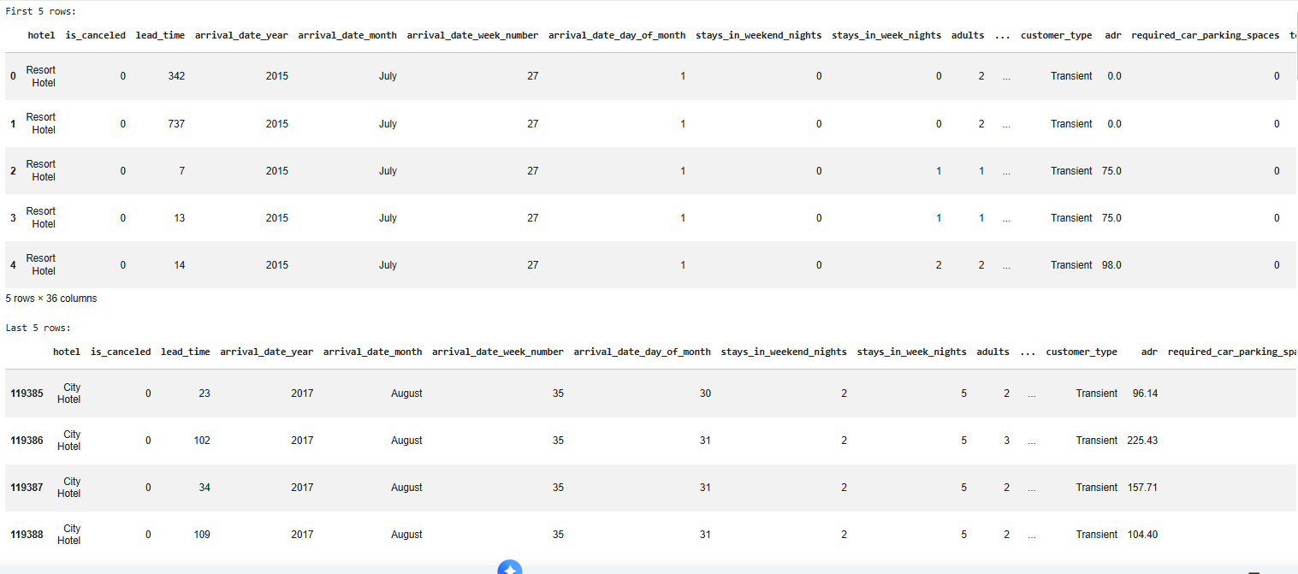
Output:

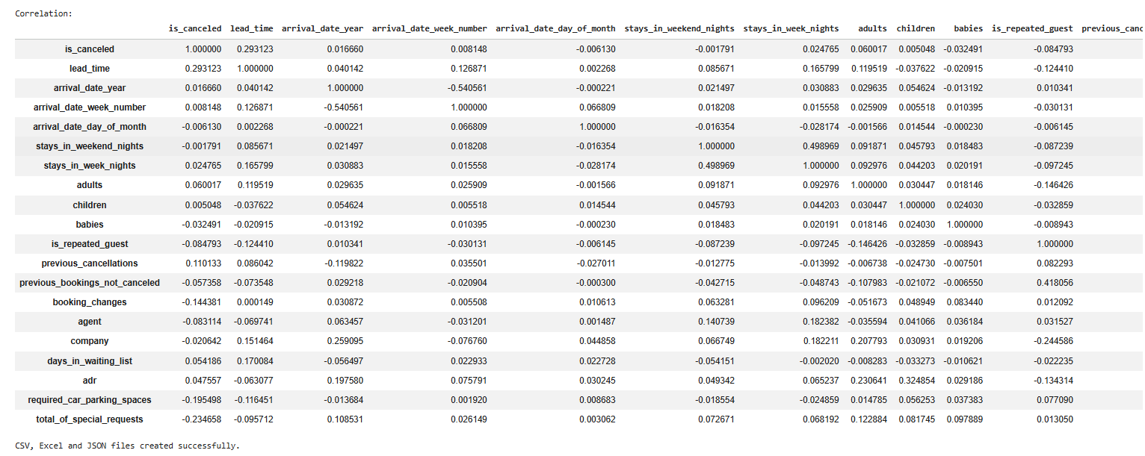
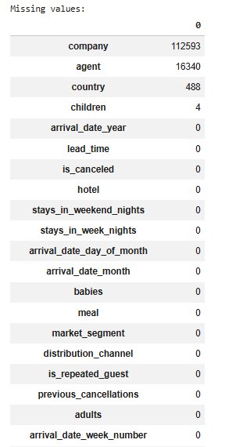
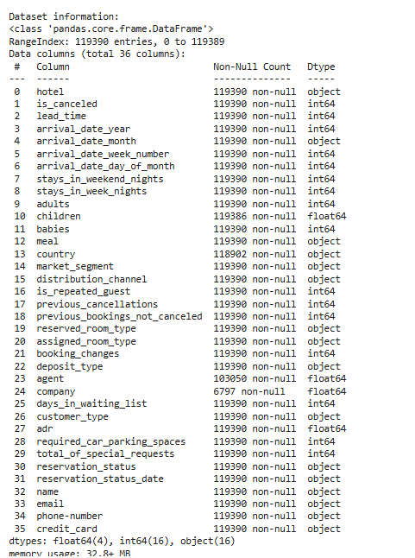

Result:

